Resume: Alton SCOTT NEWELL, JR.
1 October 2022
240 Thunderbird
Suite A
El Paso, Texas 79912
Scotnewell@gmail.com
915 276 3900

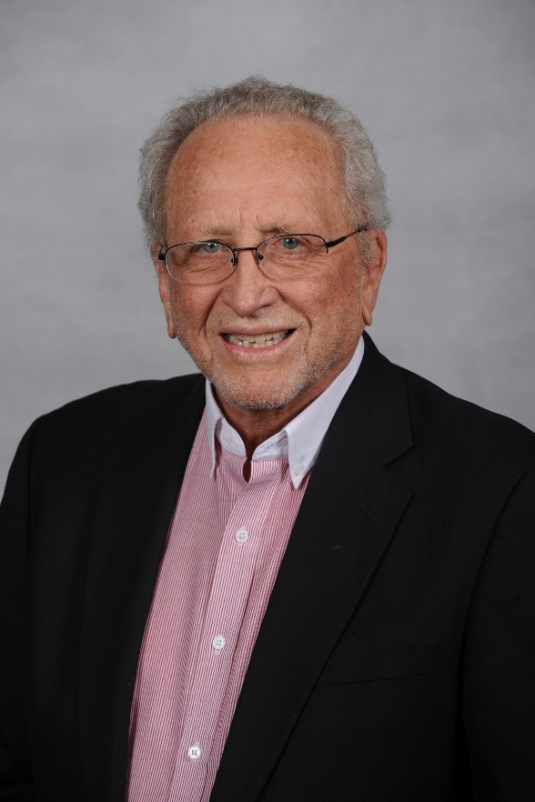

Scott Newell (83) lives in El Paso, Texas. He is Chairman and Chief Executive Officer of Newell Recycling Equipment, LLC, El Paso, Texas. He is also Vice Chairman of China Recycling Newell Equipment, Ltd. a joint venture manufacturer of all types of shredding and separation equipment located in China and is Executive Vice President of Last Step Recycling LLC, Chester, South Carolina. He is also Co-Founder and Partner of Newell Cobb Enterprises, which has a shredder plant, a marine division with Tug Boats and barges and a hopper barge building division.

Scott Newell grew up in the scrap business and for many years has been a leader in the industry. His career began by working in scrap processing plants owned by his father Alton Newell Sr. After attending Baylor University, Trinity University and Arizona State University, Scott served as manager of the Newell Salvage Co. of Phoenix, Arizona for six years from 1959 to 1965.

From the time the second Newell shredder was built in the early 1960s, Scott has had the responsibility for the daily operation of one or more shredding plants, in addition to the responsibility for the manufacturing company. During the past 56 years, Scott has been responsible for the design, manufacture and operation of shredding plants, including the direct management and guidance for the engineering personnel. As a hand’s on operator, Scott is fond of telling people that having been responsible for designing shredding plants for more than 50 years and as a result, “I have learned a lot of things to not do,….. and some things that simply must be done,”

Scott is fond of sharing this information with shredder operators around the world believing that anything that is good for the shredding industry will be good for Newell Recycling Equipment, LLC. In support of that goal, Scott has written, published and delivered more than 100 technical papers explaining how to shred and how to design separation systems to create the greatest value and how to manage these types of plants.

In addition, Scott has been very involved since the middle 1970’s with recovery of non- ferrous metals from auto shredder residue (ASR) and designed, built and operated the Newell metal recovery plants, which have processed several million tons of ASR, separating the valuable metal from the waste material.

Scott Newell has served on the national board of directors of the Institute of Scrap Iron and Steel and also its predecessor, NARI. In addition, for many years he has been an officer and or a member of the Ferrous Division and the Shredder Committees of ISRI. During 2015, Scott was presented with the prestigious “Life Time Achievement Award” from ISRI in recognition of his contributions to the industry.

He has also served on the Shredder Committee of the BIR, which is the world scrap dealers association.

During 2022, Scott Newell has been honored by Marquis Who’s Who by being selected as a Top Executive among 16 honorees selected out of 1.5 million listees. Who’s Who also recognized Scott Newell with its Life Time Achievement Award for Executive excellence.

The business activities of Scott Newell have earned the respect of the scrap processing industry. He quite often is asked to address, as a recognized expert in his industry, national and international conferences for steel makers and scrap processors.

Scott Newell is listed by Expert Engine, which is an organization that offers contacts with experts in a number of industries. He has done extensive consulting work for scrap processors and has served as an expert witness in a number of legal matters. He has also provided many economic appraisals for companies in the scrap recycling business.

Scott Newell also has many out of the industry interests and responsibilities. He served as a Trustee of the Baptist Memorial Hospital System, a 1700 bed hospital in San Antonio for 7 years. He also served as a trustee for the Mission Road Foundation for Handicapped children. He enjoys reading, writing, travel, golf, tennis, snow skiing and spending time with his 4 children, 3 grandchildren and two great grandchildren.

See www.NewellEquip.com for links to down loads for ISRI Lifetime Achievement Award, Interview with Scrap Magazine, Who’s Who Life Time Achievement Award and another link for China Recycling Newell Equipment.

Work History
1959 to 1965
Manager of Newell Salvage Company of Phoenix
Built 2nd Newell shredder under supervision of Alton Newell

1965 to 2022
Partially owned and helped manage the following companies either as direct manager or board member.
Newell Manufacturing Company
Newell Recycling Company of Phoenix
Newell Recycling Company of Tucson
Newell Recycling Company of San Antonio
Newell Salvage Company of Austin
Newell CMC partnership shredder in Dallas
Newell Recycling Company of Eagle Pass
Tulsa Metal Recycling
Oklahoma Metal Recycling
Newell Recycling Company of Atlanta
Newell Recycling Company of Houston
Newell Recycling Company of Denver
Hawaii Metal Recycling (partner with John Neu of Hugo Neu)
Alaska Metal Recycling
Puerto Rico Metal Recycling (partner with Nate Addlestone)
Eumet GMBH (partners Helmut Trapp and Cees Kroesemeijer)
Frankfurt, Germany
Peny, France
Detroit Michigan
Chicago Illinois
Southern Zinc (partners with Jerome Robinson)
Midwest Zinc (partners with Jerome Robinson)
Travel Focus (a travel agency, partner Jennie Dorner)
Newell Industries, with steel foundry
Arcelor Steel, foundry Turnout, Belgium (partner Herbert Ench chairman)
Arcelor Shredding plant in Brussels, Belgium
Great Lakes Granulating (partner Jeff Cole)
Siverhorn Golf Club (partners Bob Putt, David Robinson (Spurs basketball)
Newell Shredders UK (Derek Squires partner)
Newell Magnetics, UK (Derek Squires partner)
Kansas City Metal Recycling (Dick Galamba, partner) (now DJJ)
LMN, St. Louis, Mo. (Liff, McKinley and Newell were partners)
Salt Lake City Recycling (Jim Ramsey partner) (now DJJ)
The Shredder Company, LLC, (partner H. Inabata, Japanese chairmen of Inabata Chemicals 110 years old family business).

All the above businesses were owned and operated and then sold, most of the time to the partners. At the present time, Scott Newell has an ownership interest in the following companies:

- Newell Recycling Equipment, LLC
- Newell Equipment LLC (owner of Newell Intellectual Property)
- Newell Equipment currently have license agreements with
- Advance Hydrotech for India
- CRNE for China and Asia.
- China Recycling Newell Equipment, Ltd (CRNE) (partner is China Resource Development Corporation, which is the largest recycler in China with more than 50 recycling plants including 20 shredding plants). CRNE is licensed by Newell Equipment to build and sell Newell shredding machines. There have now been about 60 Newell shredding machines sold in China as China moves toward processing all their scrap metal generation in more modern methods.
- Last Step Recycling, LLC. Chester Technology Park, Chester, South Carolina. This is a large plant designed to recover value from ASR materials that is presently being shipped to landfills.
- Newell Cobb Enterprises (NCE). This is a scrap steel shredding plant located in South Texas on a river that is a part of the ICW, and NCE owns and operates several Tug Boats and has a fleet of hopper barges.

